# **How-To:** Charging Batteries for the X-Copter

## Daniel Maurus, Stephan Gabor 2015.04.23. Ver.1.1

**Info:** This little tutorial describes how to charge our batteries for the X-Copter-Project

|  |  |  |
| --- | --- | --- |
|  | **Identifier:** | **Information:** |
| **Hardware:** | **Battery1 (LiPo_01)** | **Name:** FlightPower Hacker evo 20 4900mAh 6S1P  **Charging:** continuous: 20C, burst: 50C, charging: 1C  **Stored in:** Speicher[31] as LiPo_01 |
| **Battery2 (LiPo_02)** | **Name:** XTRON 40C 5000mAh 6S1P  **Charging:** continuous: 40C, burst: 80C, charging: 4C  **Stored in:** Speicher[20] as LiPo_02 |
| **Battery3 (NiCd_01)** | **Charging:** loading current: 110mAh  **Stored in:** Speicher[19] as NiCa_01 |
| **Charging-Station:** | Ultra Duo Plus 60 |

We saved three configurations in the Ultra Duo for our batteries named: Lipo_01, Lipo_02 and NiCd_01

|  |  |  |  |  |
| --- | --- | --- | --- | --- |
| **Battery Overview** | | **LiPo_01** | **LiPo_02** | **NiCd_01** |
| Cell-Count: | | 6 | 6 | 4 |
| **Nominal** | Cell-Voltage | 3.7V | 3.7V |  |
| Total-Voltage | 22.2V | 22.2V |  |
| **Max.** | Cell-Voltage | **4.2**V | **4.2**V |  |
| Total-Voltage | **25**V | **25**V |  |
| **Min.** | Cell-Voltage | 3V | 3V |  |
| Total-Voltage | 18V | 18V |  |
| **Max. Charge Current** | | 4.9 A (1C) | 20 A(4C) |  |

**Hint: The maximum charge power is not above 80 W.**

**Important:** Warnings and security information are found in the documentantion-pdf:

6478_ULTRA DUO PLUS 60_de.pdf

You should read that before using the charging station as the information therein will not be in this tutorial.

# Charging Batteries:

**Current charged per charging session** = current * charging time

Refer to the datasheet of your batteries for information about max. current for charging.

**Standard-charging-current** is 1/10 of the capacity (1.7Ah capacity -> 170mA standard-charging-current)

1. Plug power cable to start charging device
2. Connect charging cables to charging station (red = plus, black = minus)
3. Recommend for LiPo’s: Connect cell adapter to “Balance” board and “Balance” board to charging station
4. We will use the CC/CV charging-mode for our batteries as fast-charging not supported by every type

# Step-by-Step-Solution

Overview

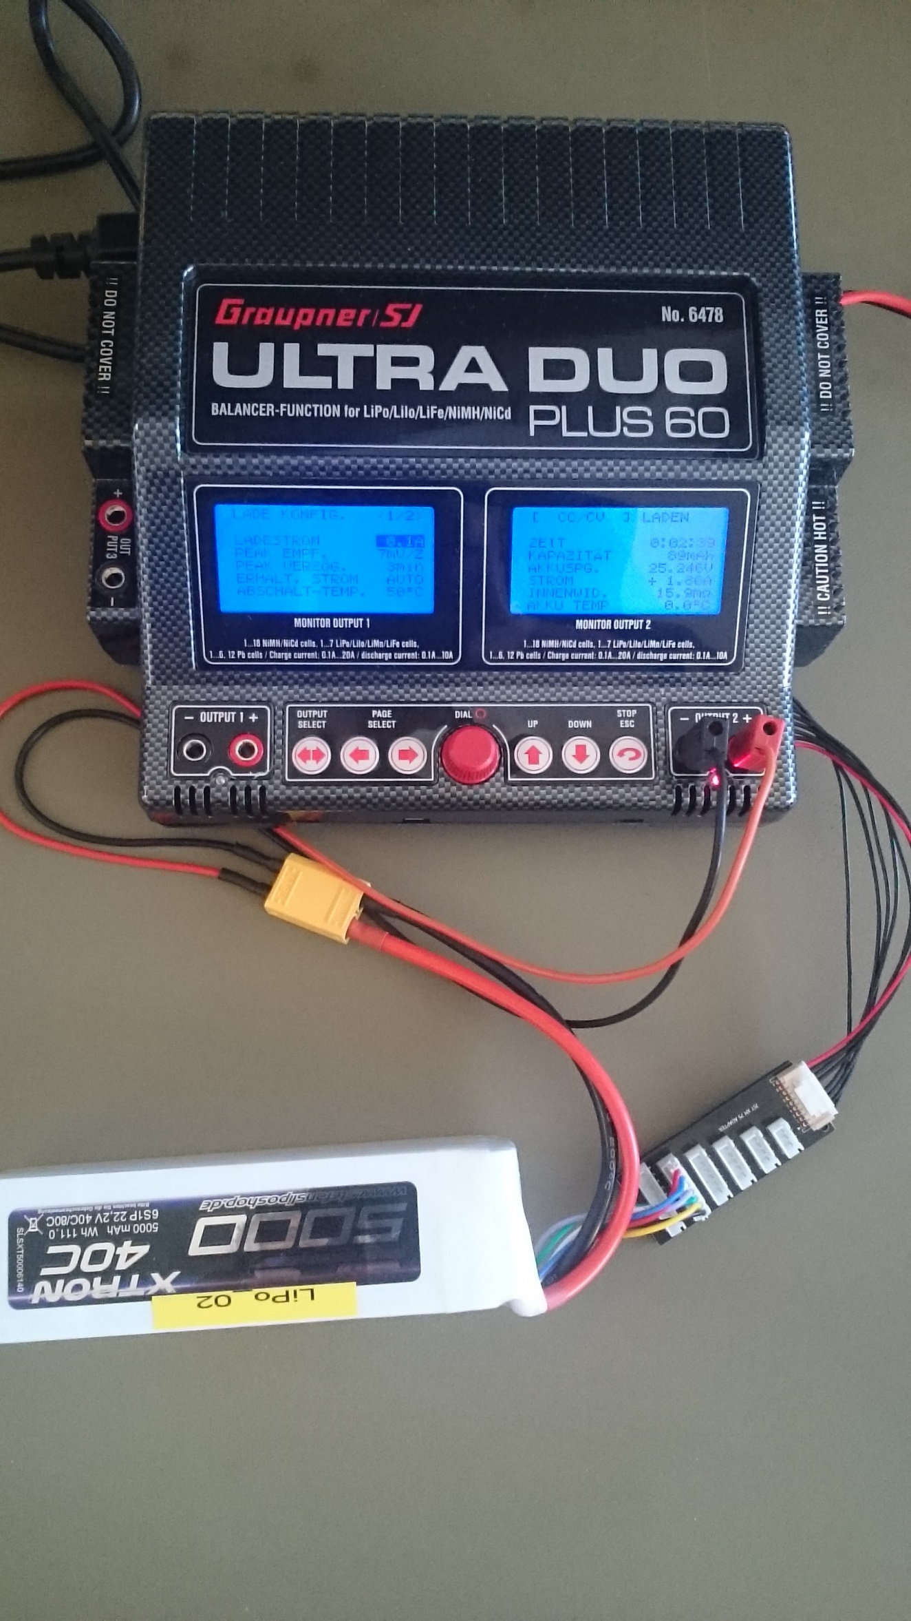

Control Interface

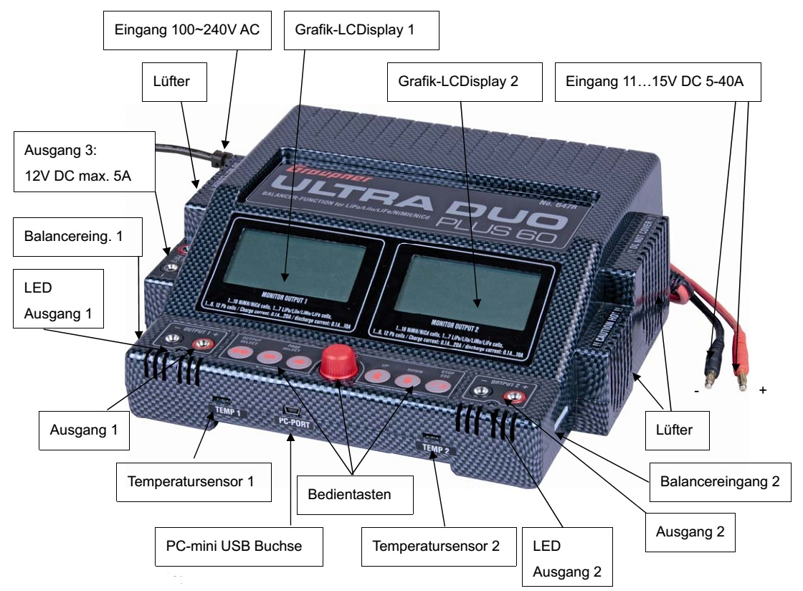

Enter “SPEICHER”-item: turn red click wheel (RCW) to select “SPEICHER” and push RCW

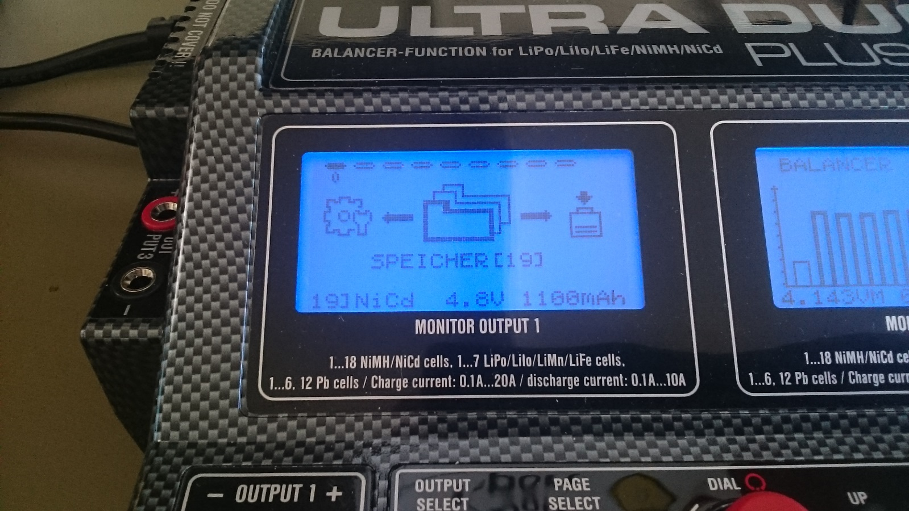

Choose save state with wheel and push STOP/ESC button to confirm (Hint: don’t push RCW! With pushing RCW you overwrite save states!)

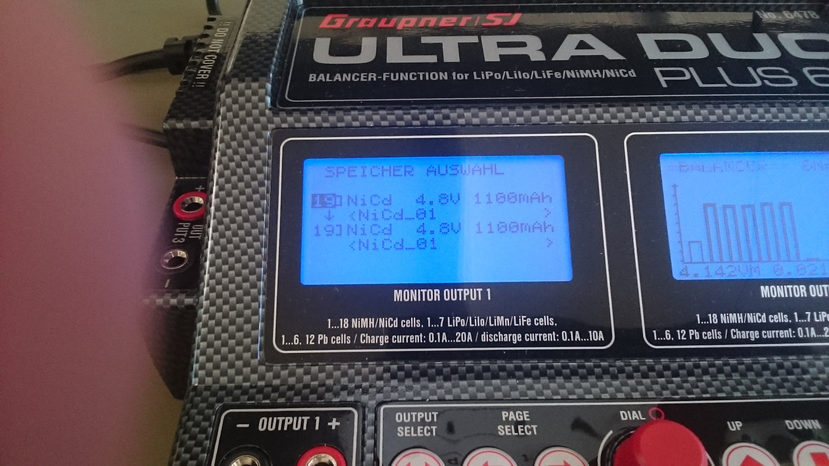

Choose Function: “LADEN” or “ENTLADEN” with RCW (here you can see the charging mode)

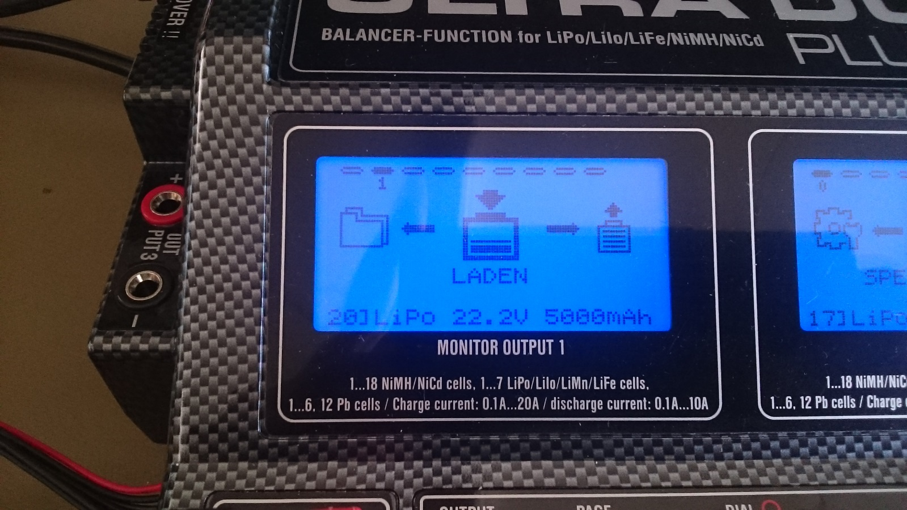

Use the CC/CV mode in the next screen (CC/CV is the common charging mode)

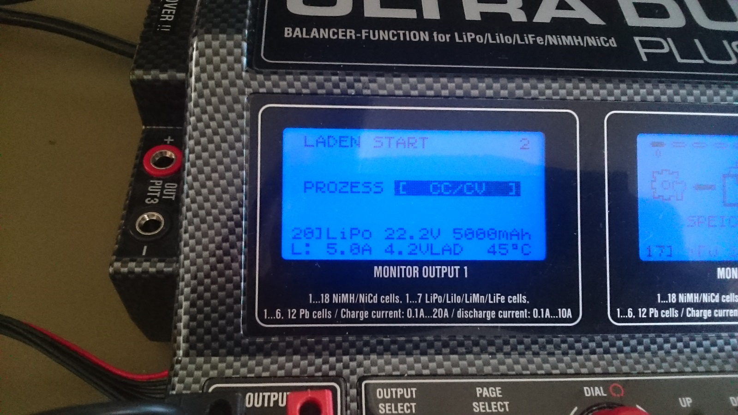

Set delay time to (VERZ. ZEIT) “AUS” (off)

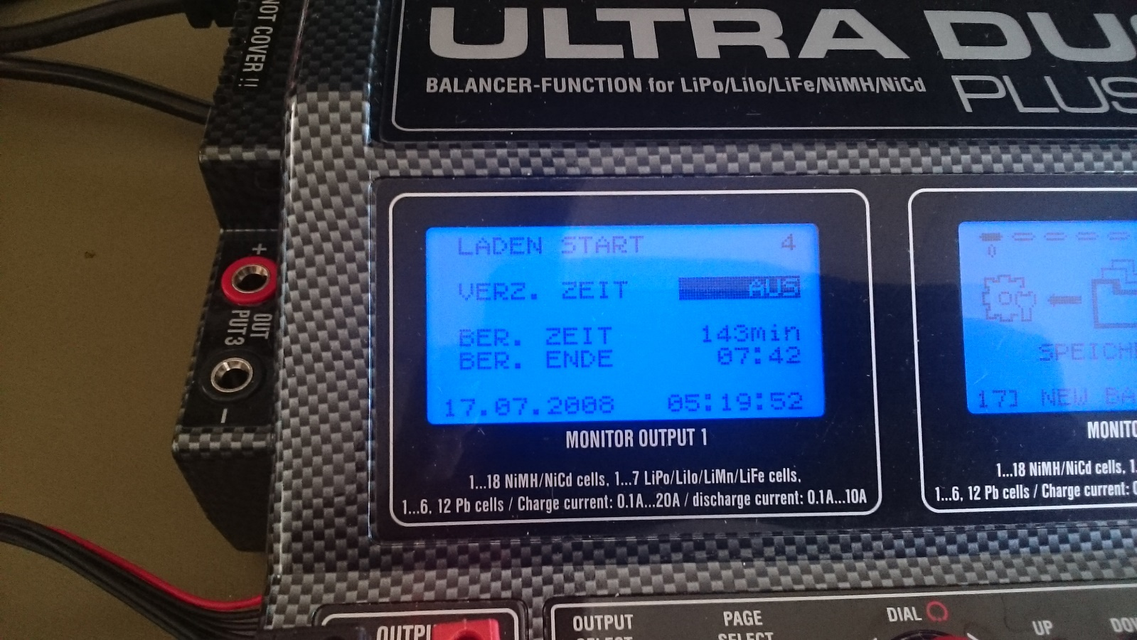

Wait until connection is checked

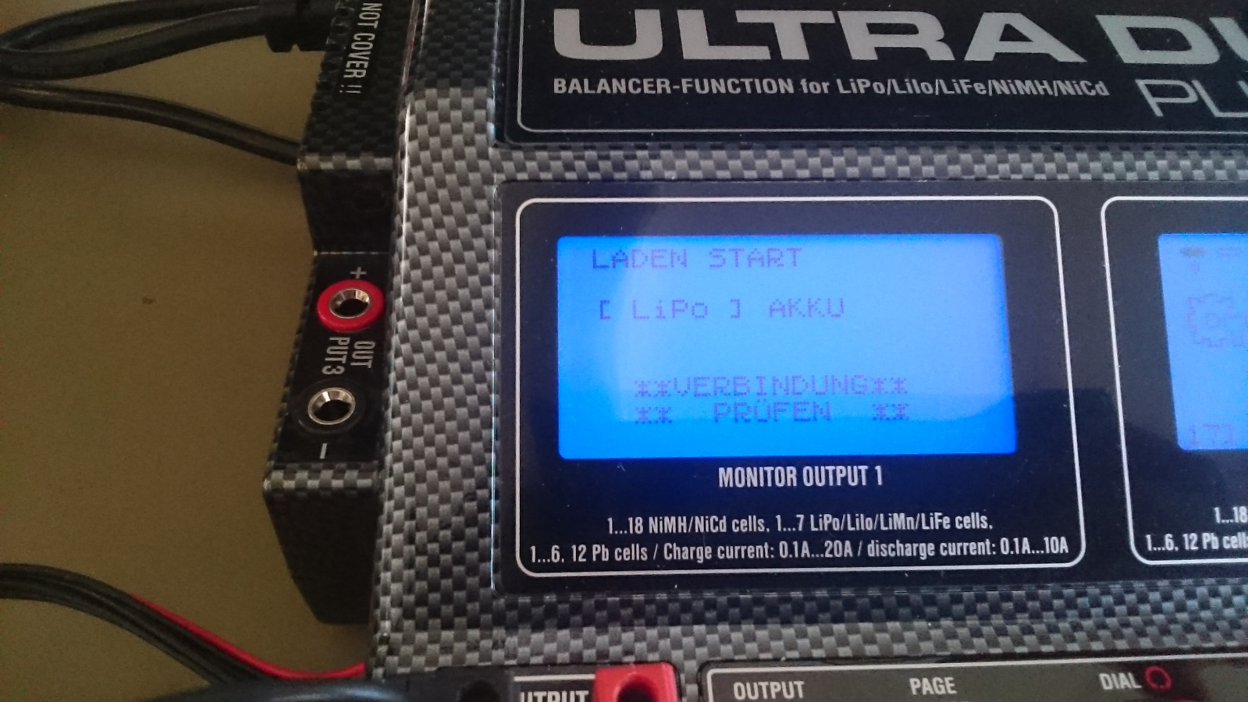

If Balance Board is connected: check cell count and confirm

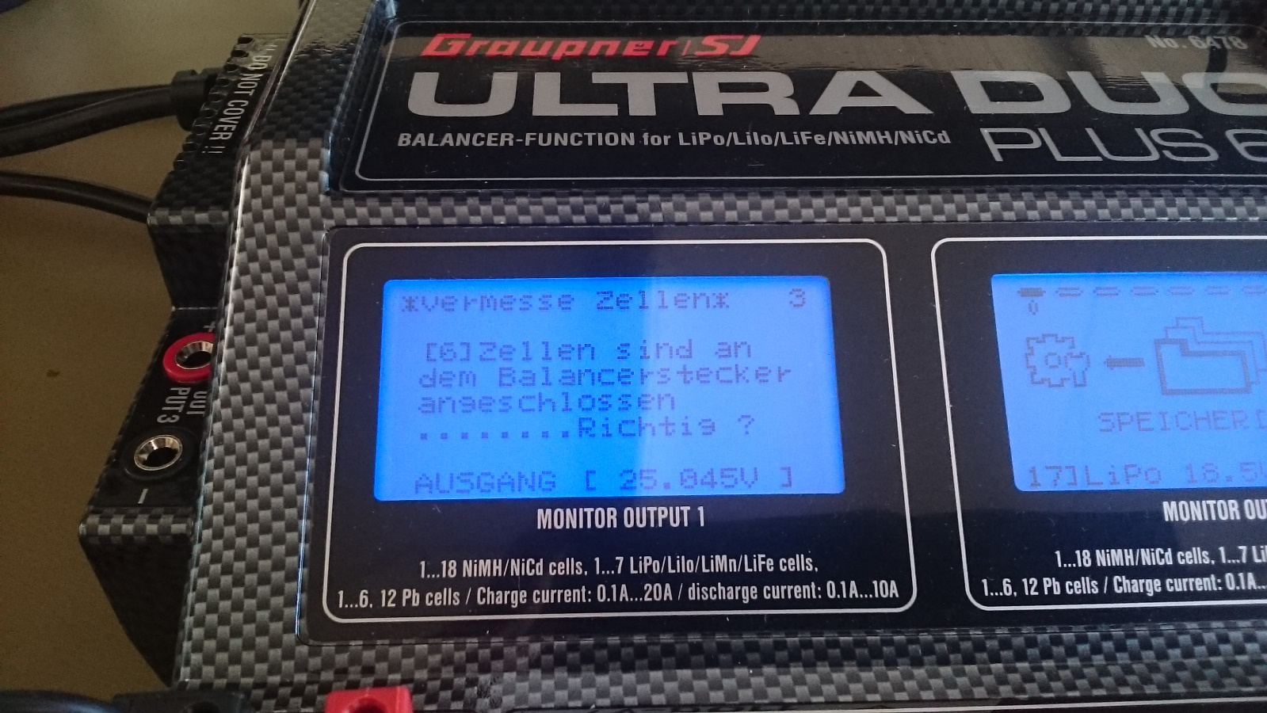

The power station starts charging and shows you current values

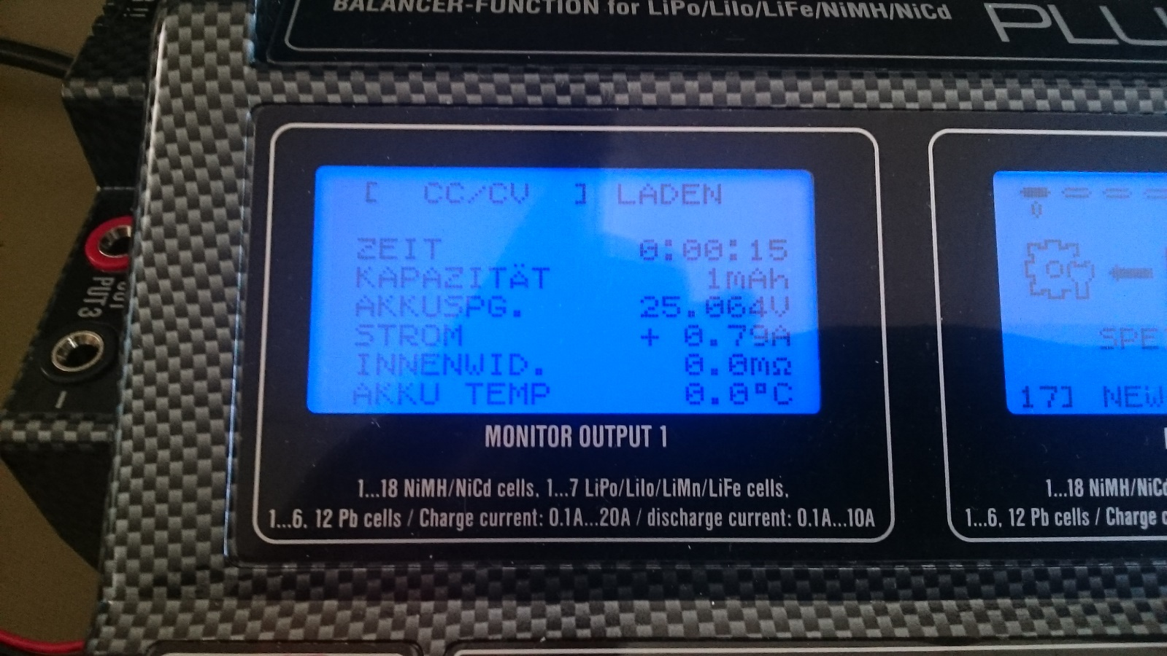

Turn the RCW to see more information

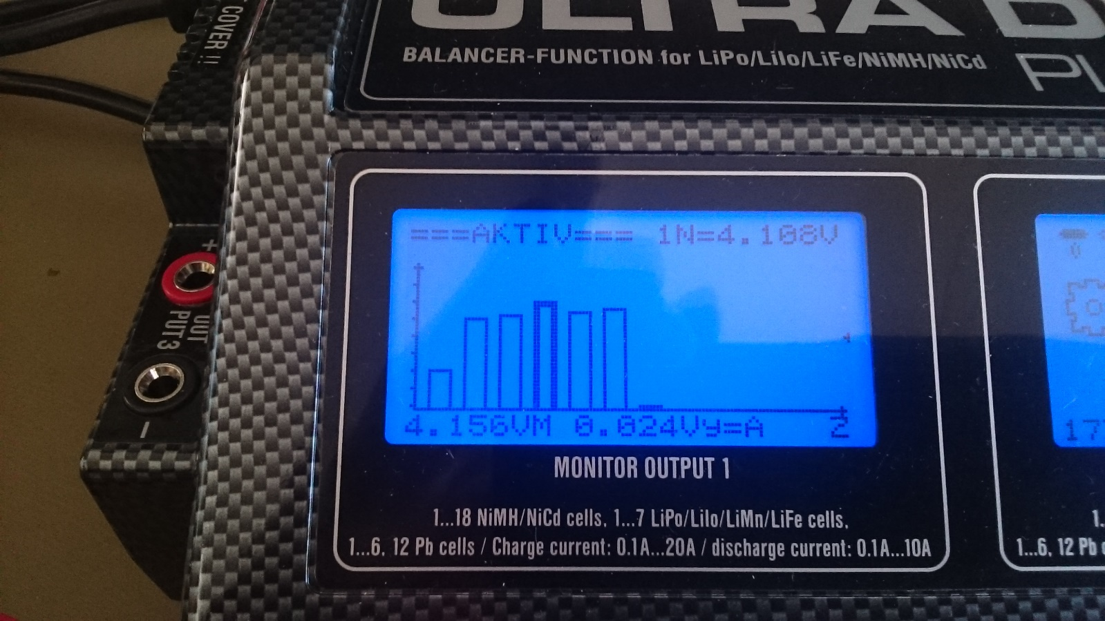

To configure the charge options press and hold RCW on “LADEN”-item until you enter der “LADE KONFIG.” settings

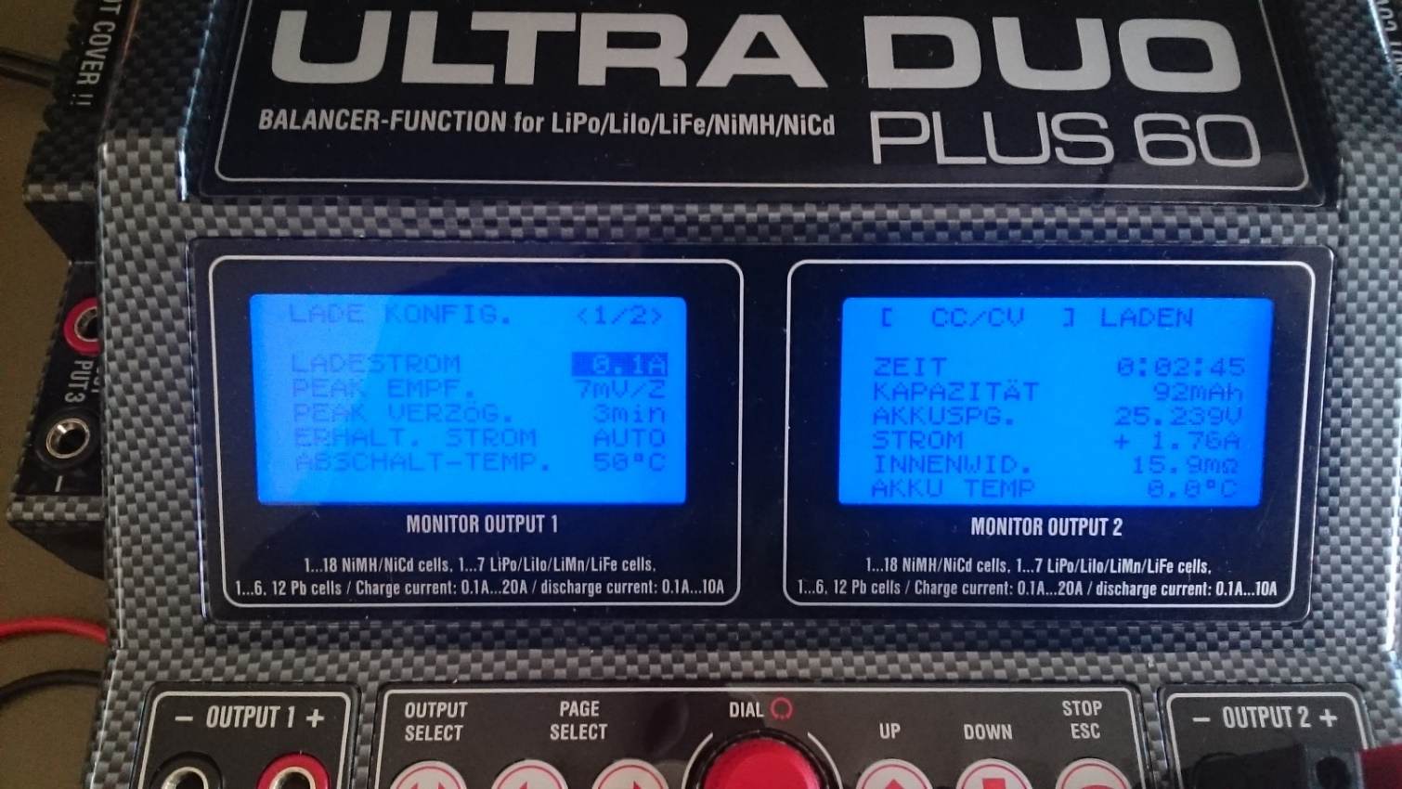

BALANCE BOARD: plug the balance board into the connector on left for channel 1 or right side for channel 2

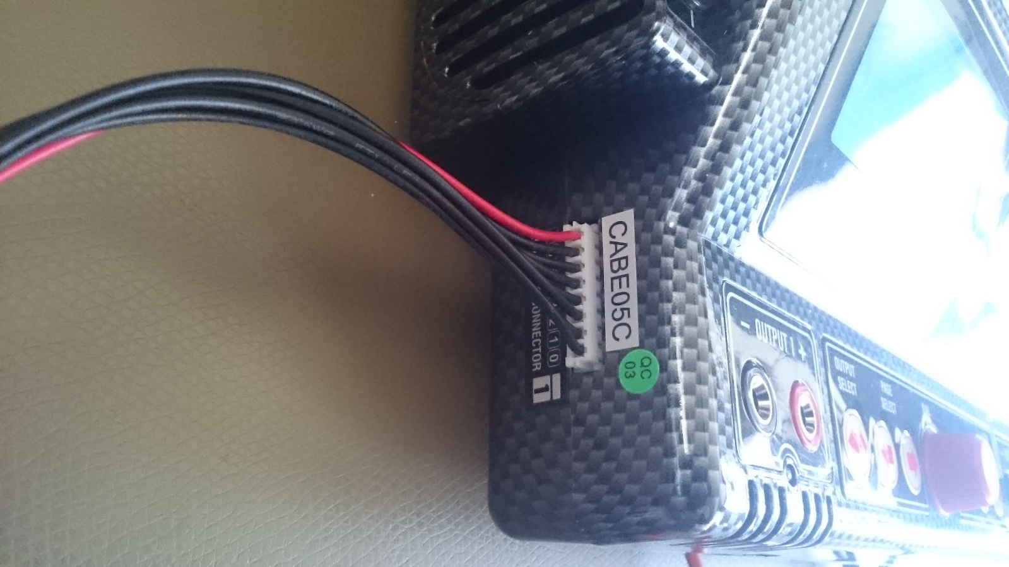

Plug the cell cable from battery to the 7S adapter – use the plug with the right count of cells

